MA1 Project: Study of the stability of a liquid bridge between two nonparallel surfaces
Context: Liquid bridge formation between two surfaces is encountered in nature and in many industrial applications such as offset printing processes, capillary adhesion, drop deposition, liquid dispensing systems…For example during offset printing, the liquid is transferred between the two rollers while stretching and breaking of the liquid bridge as we can see in figure 1b.
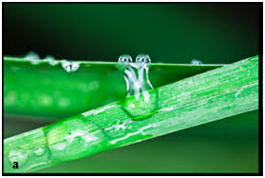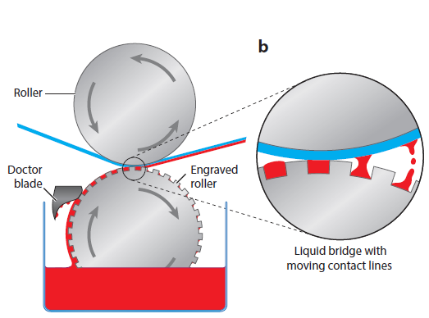
Figure 1: (a) Liquid bridge between two leaves (b) liquid bridge in a printing process [1]
When the two surfaces are not parallel, instability of the liquid bridge formed may appear. So the liquid bridge may move itself towards to the confined region. This phenomenon can be used for example for harvest condensed water drops [2] or mixture separation [3]…
Objectives:
The objective of this study is to understand why such liquid bridge instabilities are observed between two nonparallel surfaces? What are the critical parameters that influence the liquid bridge stability? A parametric study will be conducted by the student to answer these questions taking account all the parameters that can have influence on the liquid bridge instability, the tilt angle of the upper surface, the characteristics of the liquid, the contact angle of the liquid on the surfaces… The work will be divided in two parts, experiments and simulations on Surface-Evolver and Matlab.
Contact :
Pierre LAMBERT (pierre.lambert@ulb.ac.be)
Youness TOURTIT (youness.tourtit@ulb.ac.be)
References:
[1] Satish Kumar, Liquid Transfer in Printing Processes: Liquid Bridges with Moving Contact Lines, Annu. Rev. Fluid Mech. 2015. 47:67–94
[2] X. Heng, C. Luo, Bioinspired plate-based fog collectors, ACS Appl. Mater.Interfaces 6 (2014) 16257–16266.
[3] Wei Xu, Zhong Lan, Benli Peng, Rongfu Wen, Yansong Chen & Xuehu Ma, Directional Movement of Droplets in Grooves: Suspended or Immersed?, Scientific Reports 6, Article number: 18836 (2016)
Suggested additional reading:
- Mohammadmehdi Ataei, Tian Tang, Alidad Amirfazli, Motion of a liquid bridge between nonparallel surfaces, Journal of Colloid and Interface Science 492 (2017) 218–228
- Cheng Luo and Xin Heng, Separation of Oil from a Water/Oil Mixed Drop Using Two Nonparallel Plates, Langmuir 2014, 30, 10002−10010

