Study of “variable stiffness”-based medical tools
Promoter: Pierre Lambert Supervisor: Loïc Blanc – loic.blanc@ulb.ac.be
Candidates profile: ElectroMechanical / Biomedical / Civil / Chemical engineering
Description: The goal of this project is to study different solutions (mainly about design and performances) for controllable stiffness solutions. After a short literature review, one (or more) solution(s) will be developed (and compared). The candidate will choose which solutions are the best to develop and to evaluate. Some solutions have already been selected for this work.
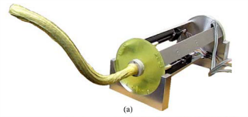
The first possibility is the application of “Granular Jamming” mechanism to biomedical tools. Granular material (e.g. glass beads, sand, ground coffee) is packed in a membrane. When working at atmospheric pressure (normal conditions), the system is flexible as a fluid. When vacuum is applied in the membrane, the system becomes much stiffer like a solid (http://y2u.be/zhIHAHmHpow). This change of stiffness is beneficial for biomedical or robotics applications.
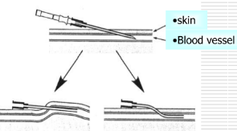
A second concept that may be studied is the “Layer Jamming” mechanism that can be applied to biomedical tools. Layers (e.g. sheets of polymer, paper) are packed in a membrane. When working at atmospheric pressure (normal conditions), the system is flexible. When vacuum is applied in the membrane, the system becomes much stiffer (https://vimeo.com/73164578).
A third solution is the use of Shape Memory Polymers. Shape Memory Polymers are polymers that may present a huge change in stiffness (Young Modulus) for a little variation of temperature. This change of stiffness is beneficial for biomedical or robotics applications.
Goal: The goal of this project is to study the application of these mechanisms that enable the change of stiffness. The performances in the rigid and flexible states have to be quantified, compared and justified. Experimental work will put into practice the theoretical model and principles.
Tasks: First, a short literature review will be performed to understand the context of this work and the possible solutions that may be studied. Several promising solutions have already been highlighted, but new mechanisms could be proposed, studied and applied. Innovative use and design of these principles for biomedical tools (first at larger scales to ease the conception and to validate the designs before going to final scale) and optimisation of the performances of the chosen method.
References:
Kuder, I. K., Arrieta, A. F., Raither, W. E., & Ermanni, P. (2013). Variable stiffness material and structural concepts for morphing applications. Progress in Aerospace Sciences, 63, 33-55.
Huang 2012
Cheng, N. G. (2013). Design and analysis of jammable granular systems (Doctoral dissertation, Massachusetts Institute of Technology).
Kim, Y. J., Cheng, S., Kim, S., & Iagnemma, K. (2013). A novel layer jamming mechanism with tunable stiffness capability for minimally invasive surgery. IEEE Transactions on Robotics, 29(4), 1031-1042.
Leng, J., Lan, X., Liu, Y., & Du, S. (2011). Shape-memory polymers and their composites: stimulus methods and applications. Progress in Materials Science, 56(7), 1077-1135.

