MA1 Project: Effect of contact angle hysteresis on the liquid bridge breakup and on the liquid transfer ratio between the two surfaces
Context:
Transfer of liquid droplets is encountered in many applications such as offset printing processes, capillary adhesion, drop deposition, packaging industry (dispensing of glue)…To do so, one of the most widely known transfer method is stretching liquid bridge formed between two surfaces. While stretching a liquid bridge above a certain height threshold, the liquid bridge breaks, hence a part of liquid is transferred from one to another surface.
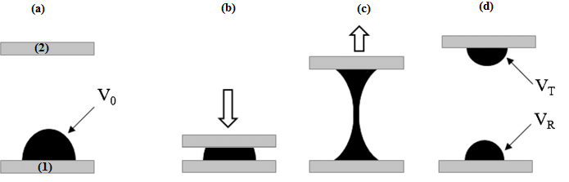
Figure 1: Droplet separation process [1]: the transfer ratio of interest is defined as the volume transferred (V_{T}) over the initial volume of the droplet (V₀)
For a series of applications, it is important to be able to control (ie. to maximize or to minimize) this liquid transfer:
- ink transfer should be increased for offset gravure printing;
- among the framework of handling (= picking and placing) small electrical or watch components with capillary forces, the residual liquid left on the component should be minimized.
In this process, gravity is usually negligible at the droplets scale. At the contrary, other parameters play a key role in explaining and predicting the transferred volume, among which the contact angle hysteresis. This hysteresis is the difference between the advancing contact angle (step b) and the receding contact angle (step c). It influences the liquid bridge breakup and hence the transferred volume [2].
Objectives:
The objective of this study is to understand how the contact angle hysteresis influences the behaviour of the liquid bridge breakup and hence the transfer ratio. By using different liquids and surfaces that can permit different contact angle hysteresis. The student will answer to these questions on doing both, experiments and simulations (on Surface-Evolver, Matlab).
Contact :
Pierre LAMBERT (pierre.lambert@ulb.ac.be)
Youness TOURTIT (youness.tourtit@ulb.ac.be)

References:
[1] Hyun Wook Kang, Hyung Jin Sung, Taik-Min Lee, Dong-Soo Kim and Chang-Jin Kim, Liquid transfer between two separating plates for micro-gravure-offset printing, J. Micromech. Microeng. 19 (2009) 015025 (9pp).
[2] H. Chen, A. Amirfazli and T. Tang, Modeling Liquid Bridge between Surfaces with Contact Angle Hysteresis, Langmuir 2013, 29, 3310−3319
Suggested additional reading:
- Hong, S.-J.; Chou, T.-H.; Chan, S. H.; Sheng, Y.-J.; Tsao, H.-K, Droplet Compression and Relaxation by a Superhydrophobic Surface: Contact Angle Hysteresis. Langmuir 2012, 28, 5606−5613.
- H. Chen, T. Tang and A. Amirfazli, Fast Liquid Transfer between Surfaces: Breakup of Stretched Liquid Bridges, Langmuir 2015, 31, 11470−11476

